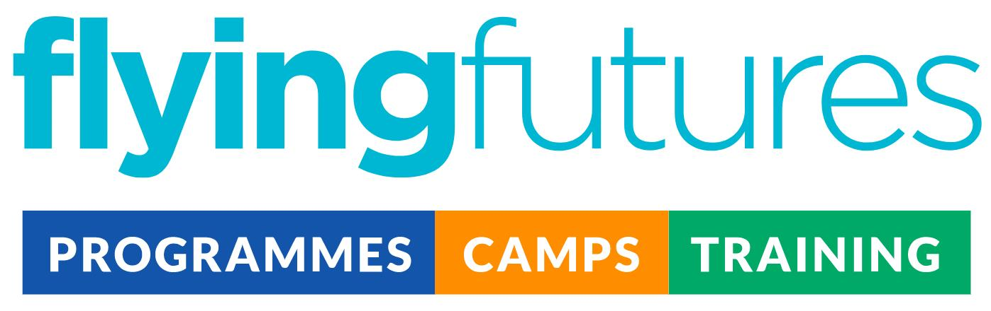
Job Description: Youth Leader

Location options | We’re looking for staff across the following areas:  North Yorkshire - Selby  East Yorkshire - Pocklington, Market Weighton, Bridlington, Snaith  South Yorkshire - Doncaster  West Yorkshire - Bradford
Salary | £12.71 per hour
The role | The Youth Leader is required to inspire, lead and provide a safe space for our participants across a range of programmes. Ensuring full safety through-out, the Youth Leader will deliver high quality, engaging and fun sessions, ranging from multi-sports to creative arts.  We are looking for staff who are committed to making our programmes an enriching experience for young people.  The post holder will need energy, enthusiasm, flexibility and a creative approach to be successful in this role.
Line management | None
Reporting to | Deputy Operations Manager
Application process | Application form > Interview > DBS and reference checks.  Flying Futures has a commitment to safeguarding and protecting all children and adults, see our Safeguarding Policy Statement  All personal data related to a job applicant is processed in accordance with our GDPR Privacy Notice for Job Applicants.

Core Duties

Responsible for | - Delivering activities and supporting in the smooth running of a high quality programme  - Maintaining relationships and reputations with stakeholders, schools, partners and families who attend our programme.  - Follow programme guidance and reporting where necessary  - Completing administration tasks where required  - Support and deliver activities in a safe and proper manner.  - To be a positive role model to young people  - To inspire and encourage children to develop their skills and achieve objectives of the programmes
Liaising with | Venue contacts, families, Flying Futures staffing team and any other relevant organisations.

Personal Specification

Essential | Behaviours | Beneficial
Ability to present confidently and bring the programme to life  Assertiveness, resilience and confidence to achieve desired results  Good communication and time management skills  Flexible, creative, enthusiastic, empathetic and non-judgemental with a willingness to understand others | Uses initiative to adapt and change style quickly  Strives for continuous improvement  Persistent and resilient, yet calm under pressure  Warm, humble and approachable personality  A strong team ethic | First aid certificate  Experience working with young people  Specialised knowledge or experience in a skill that can be delivered on this programme  Full driving licence and a car/access to public transport

